Kobee Raveendran

PA4 – Hyperparameter Tuning

**Hyperparameter Tuning Report**

2) Accuracy after training on 12 epochs (default): 99.08%

3) model: conv 🡪 conv 🡪 max-pooling 🡪 dropout (and flatten to prepare output for FC layers) 🡪 FC 🡪dropout 🡪 FC

4) Accuracy after training on 30 epochs: 99.12%

Loss after training on 30 epochs: 0.02866379

Part 4 accuracy plot:

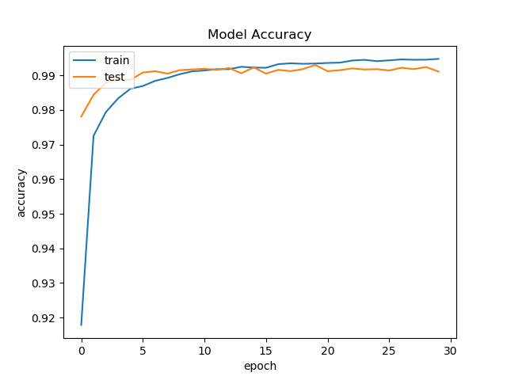

5) loss plot:

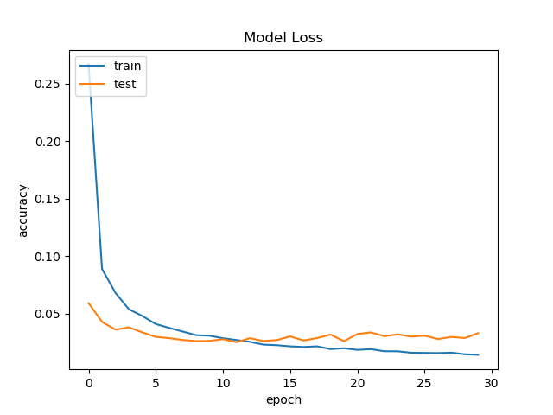

6) test accuracy: 99.07%

Test loss: 0.0487900099

Train + test accuracy plot:

